**COVID CASES TRACKER**

*A*

*Mini Project Report*

*Submitted in partial fulfilment of the*

*Requirements for the award of the Degree of*

**BACHELOR OF ENGINEERING**

IN

**INFORMATION TECHNOLOGY**

By

**B. HARSHAVARDHAN (1602-19-737-072)**

**P. SATYA TARUN (1602-19-737-101)**

**A. VARUN KUMAR REDDY (1602-19-737-121)**



**Department of Information Technology**

**Vasavi College of Engineering (Autonomous)**

**(Affiliated to Osmania University)**

**Ibrahimbagh, Hyderabad-31**

**2020**

**Vasavi College of Engineering (Autonomous)**

**(Affiliated to Osmania University)**

**Hyderabad-500 031**

**Department of Information Technology**



We, B.HarshaVardhan , P.SatyaTarun and A.Varun Kumar Reddy bearing hall ticket numbers, 1602-19-737-072, 1602-19-737-101 and 1602-19-737-121, hereby declare that the project report entitled “COVID CASES TRACKER” is submitted in partial fulfilment of the requirement for the award of the degree of Bachelor of Engineering in Information Technology.

This is a record of bonafide work carried out by us and the results embodied in this project report have not been submitted to any other university or institute for the award of any other degree or diploma.

**B. HARSHAVARDHAN**

**(1602-19-737-072)**

**P. SATYA TARUN**

**(1602-19-737-101)**

**VARUN KUMAR REDDY**

**(1602-19-737-121)**

(Faculty In-Charge) (Head,Dept of IT)

ACKNOWLEDGEMENTS

The satisfaction that accompanies the successful completion of this project would not be in complete without the mention of the people who made it possible, without whose constant guidance and encouragement would have made efforts go in vain. We consider ourselves privileged to express gratitude and respect towards all those who guided us through the completion of this project.

We thank our faculty (Prasanna mam) because they clarified our few doubts regarding to the project, gave few suggestions and guided us by which we successfully completed our project.

Last but not the least, we wish to thank our parents for financing our studies in this privileged Vasavi College of Engineering as well as for constantly encouraging us to learn engineering. Their personal sacrifice in providing this opportunity to learn engineering is gratefully acknowledged.

ABSTRACT

Our application allows the user to view number of covid cases based on user’s choice. User will have number of choices to view number of cases. User can select whether he wants to know number of cases on a particular date or in a particular place (national or international).

If the user selects “by date” option user can choose whether he wants to know number of cases on whole day or up to selected time and based on user’s choice number of cases, deaths and recoveries will be displayed.

If the user selects “by Place” option user can choose whether he wants to know number of cases in a particular state (in India) or particular country/continent and based on user’s choice number of cases, deaths and recoveries will be displayed.

Even death rate and recovery rate will be displayed based on user’s choice (on a particular date or particular month).

**Table of contents**

|  |  |
| --- | --- |
| **Topic** | **Page Number** |
| **Introduction** | 6 |
| **Technology** | 7 |
| **Proposed Work** | 8 - 14 |
| **Results** | 15-23 |
| **Additional Knowledge Acquired** | 24 |
| **Conclusions and Future work** | 25 |
| **References** | 26 |

INTRODUCTION

ABOUT THE PROJECT

Our project is “Covid Cases Tracker”. Our applications allows the user to view number of covid cases, number of deaths, number of recoveries at a particular place on a particular day. We can also view the recovery rate and death rate. To provide this data we first collected a file which has all this information.

WHAT WE PRIORITIZED

Data is the most important part for our project. So, we first collected a file which has all the data which includes total cases, deaths in all states (India) and all the continents across the world. Then, we wrote the code first for displaying information about states and then continents one after the other by reading data from csv file. At last we calculated death and recovery rates.

OBJECTIVE OF OUR PROJECT

The main aim of our project is to allow user to view number of cases , recoveries, deaths, recovery rate, death rate anywhere across the world and any state (India).

TECHNOLOGY

All computer software needs certain hardware components or other software resources to be present, in order for computers to be used efficiently. These prerequisites are known as System Requirements. Within this, we have two types – Software Requirements and Hardware Requirements.

## SOFTWARE REQUIREMENTS

Software Requirements deal with defining the software resource requirements and prerequisites that need to be installed on a computer to provide optimal functioning of an application. These preconditions are generally not included in the software installation package and need to be installed separately.

In order to use CODIAC, one should have the following:

* **Operating System:** Windows 7 and above
* **C Compiler:** GNU Compiler Collection (GCC)
* **Editor:** Vim editor .

## HARDWARE REQUIREMENTS

Hardware requirements refer to the common set requirements defined by any operating system or software application and are usually the physical computer resources. In this, we look into the architecture, processing power, memory, secondary memory, display adapter and peripherals.

In order to use this project, one should have the following:

* + - **Processor:** Intel Pentium processor and above
    - **Memory:** 4 GB RAM and above

**Proposed work**

1. Design
   * 1. Use case diagram

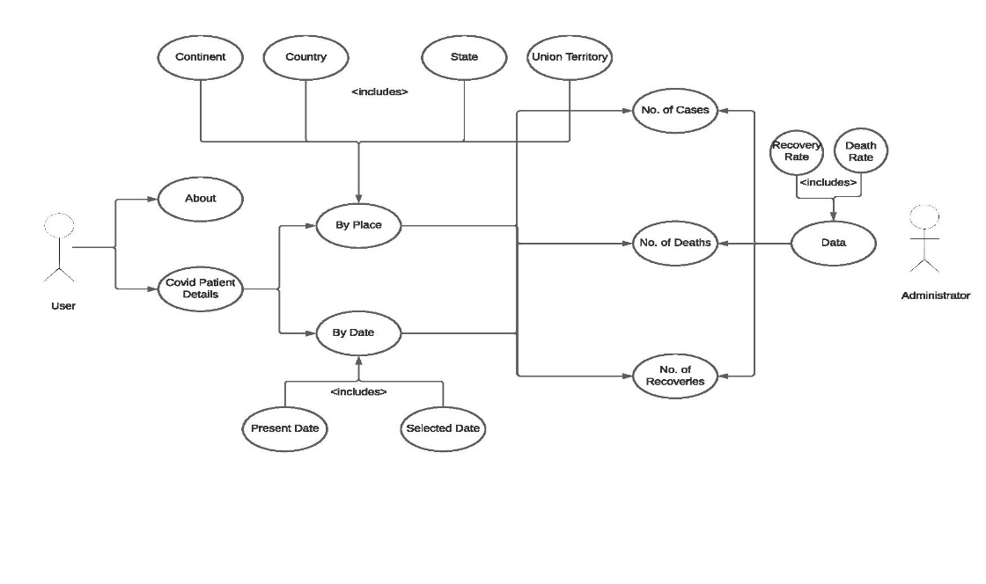

FLOW CHART:

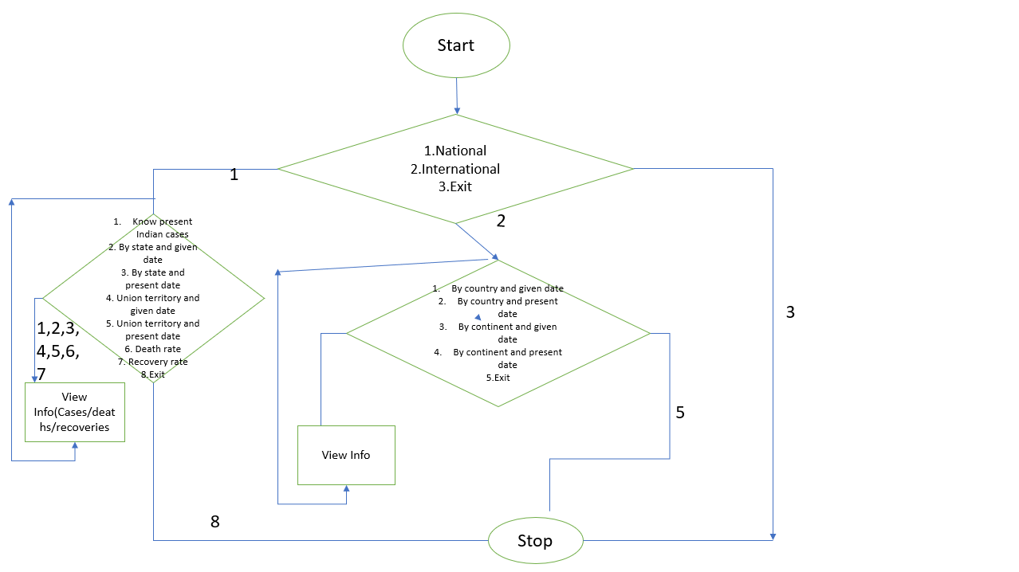

1. Implementation
   * 1. Description of main modules/classes/components.

We have 2 main modules namely “National” and “International”. There are again few choices in “National” module. User can select whether he want to know number of cases in India or in a particular state or in a particular union territory and death rate, recovery rate by given date or present date. List of states and union territories is displayed and user needs to enter date and based on user’s choice active cases or total cases, number of deaths, recoveries death and recovery rates are displayed by calling appropriate sub modules.

There are again few choices in “International” module. User can select whether he want to know number of cases in a particular continent or in a particular country by given date or present date. List of continents is displayed and based on user’s choice total cases and deaths are displayed by calling appropriate sub modules.

* + 1. Any specific algorithms/logic to be highlighted.

void deathRate(FILE *fp,const char* startDate,const char* endDate, const char* state){

fseek(fp,0,SEEK_SET);

char buf[1000];

char *token;

char *arr[1000];

int j;

int flag=0;

int startTotalCases,endTotalCases,startDeaths,endDeaths;

for(int i=0;i<8500;i++){

j=0;

if(fgets(buf,1000,fp)!=NULL){

token = strtok(buf,",");

while(token!= NULL){

arr[j++]=token;

token = strtok(NULL,",");

}

if(!strcmp(arr[2],state)){

if(!strcmp(arr[1],startDate)){

startTotalCases=atoi(arr[3]);

startDeaths=atoi(arr[6]);

}

if(!strcmp(arr[1],endDate)){

endTotalCases=atoi(arr[3]);

endDeaths=atoi(arr[6]);

}

flag = 1;

break;

}

}

/*else{

printf("NULL");

}*/

}

if(flag==0){

printf("No data for given inputs\n");

}

else{

printf("\n\t\t________________________________________________________________________\n\n");

printf("\t\tDeath rate between %s and %s in %s : %.2f%%",startDate,endDate,state,(((float)(endDeaths-startDeaths))*100)/(endTotalCases-startTotalCases));

printf("\n\t\t________________________________________________________________________\n\n");

}

}

ALGORITHM:

1. Menu is displayed to user which shows all the 12 months.
2. User need to enter a number (1 to 12) for particular month.
3. Based on user’s choice start date and end date of month are assigned by calling suitable functions.
4. Then total cases and deaths are read from the file on starting date and end date for that particular month and state.
5. Death rate is calculated by following formula:

( ( enddeaths - startdeaths ) / ( endcases – startcases ) ) * 100

1. It is converted into float value and then displayed.
2. Github links and folder structure.

Github links:

<https://github.com/andevarun/mini-project->

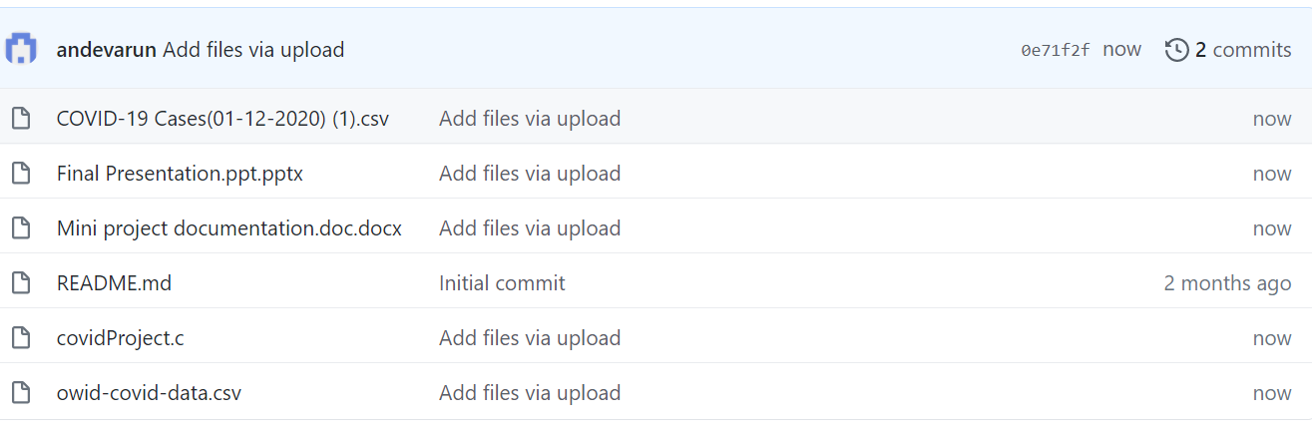

1. Testing

We approached testing our console application by analysing each module separately. First, we coded the requirements and then manually tested each feature present in the module to cover any gaps that might occur.

First a menu is shown (national/international/exit) to the user. Then if the user chooses “national” option then the user is shown a menu again 1. Know the Present Indian Cases, 2.Get Data By State and given date, 3.Get Data By State and present date, 4.Get Data By Union Territories and given date 5.Get Data By Union Territories and present date 6.Know Death Rate 7.Know Recovery Rate and 8.exit.

If the user chooses option 1 then the total cases and deaths in India is displayed. If the user chooses option 2 then list of states is displayed and user is prompted to enter the state and enter date and enter whether to display cases/deaths/recoveries and accordingly data is printed on the console. If date is in incorrect format then it is displayed as “invalid input”. If data is not present then it is displayed as “No data for given inputs”.

If the user chooses option 3 then list of states is displayed and user is prompted to enter state and enter whether to display cases/deaths/recoveries and accordingly data is printed on the console. If data is not present then it is displayed as “No data for given inputs”.

If the user chooses option 4 then list of union territories is displayed and user is prompted to enter union territory and enter date and enter whether to display cases/deaths/recoveries and accordingly data is printed on the console. If date is in incorrect format then it is displayed as “invalid input”. If data is not present then it is displayed as “No data for given inputs”.

If the user chooses option 5 then list of union territories is displayed and user is prompted to enter union territory and enter whether to display cases/deaths/recoveries and accordingly data is printed on the console. If data is not present then it is displayed as “No data for given inputs”.

If the user chooses option 6 then list of states is displayed and user is prompted to enter the state and whether to display death rate on a particular date or particular month and data is displayed. If data is not present then it is displayed as “No data for given inputs”.

If the user chooses option 7 then list of states is displayed and user is prompted to enter the state and whether to display recovery rate on a particular date or particular month and data is displayed. If data is not present then it is displayed as “No data for given inputs”.

If the user chooses option 8 program is terminated.

If the user chooses “international” option, again a menu is displayed a. Country and given date b. Country and present date c. Continent and given date d. Continent and present date e. Exit

If the user chooses option ‘a’ then user is prompted to enter country name and date and data (total cases and deaths) are displayed. If date is in incorrect format then it is displayed as “invalid input”. If data is not present then it is displayed as “No data for given inputs”.

If the user chooses option ‘b’ then user is prompted to enter country name and data (total cases and deaths) are displayed. If data is not present then it is displayed as “No data for given inputs”.

If the user chooses option ‘c’ then user is displayed list of continents and prompted to enter continent and date and data (total cases and deaths) are displayed. If date is in incorrect format then it is displayed as “invalid input”. If data is not present then it is displayed as “No data for given inputs”.

If the user chooses option ‘d’ then user is displayed list of continents and prompted to enter continent and data (total cases and deaths) are displayed. If data is not present then it is displayed as “No data for given inputs”.

If the user chooses option ‘e’ program is terminated.

If the user chooses option ‘exit’ option program is terminated.

**Results**

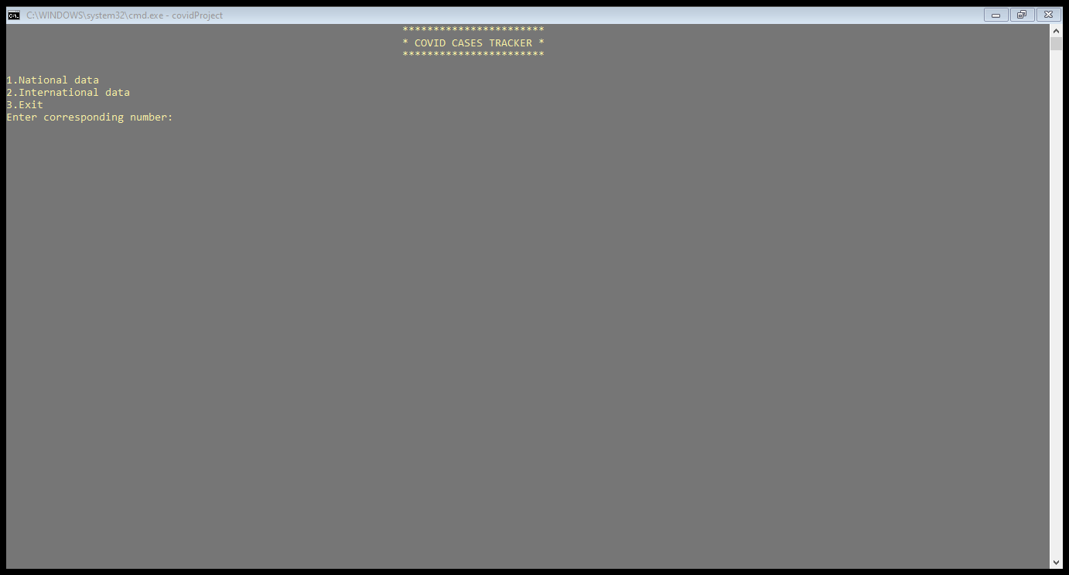

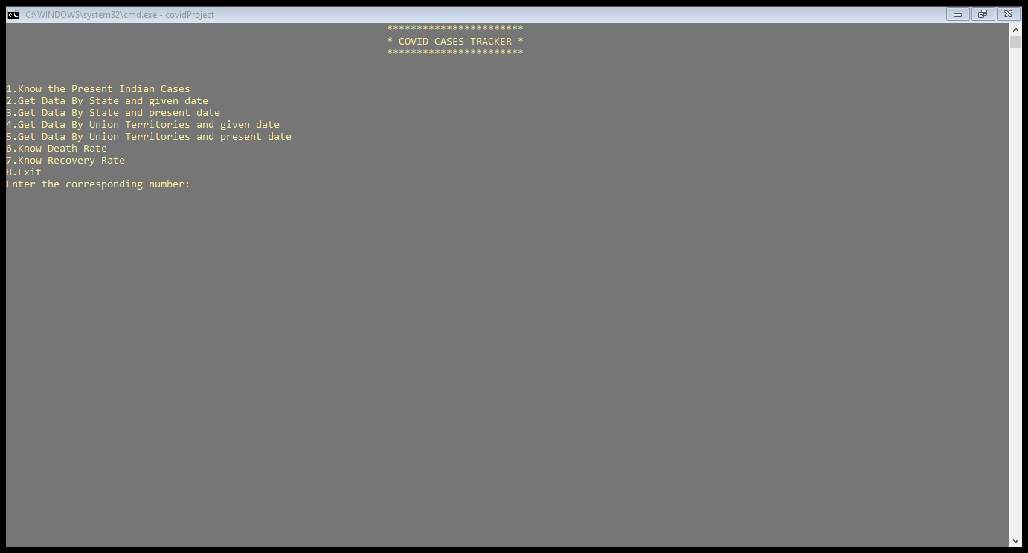

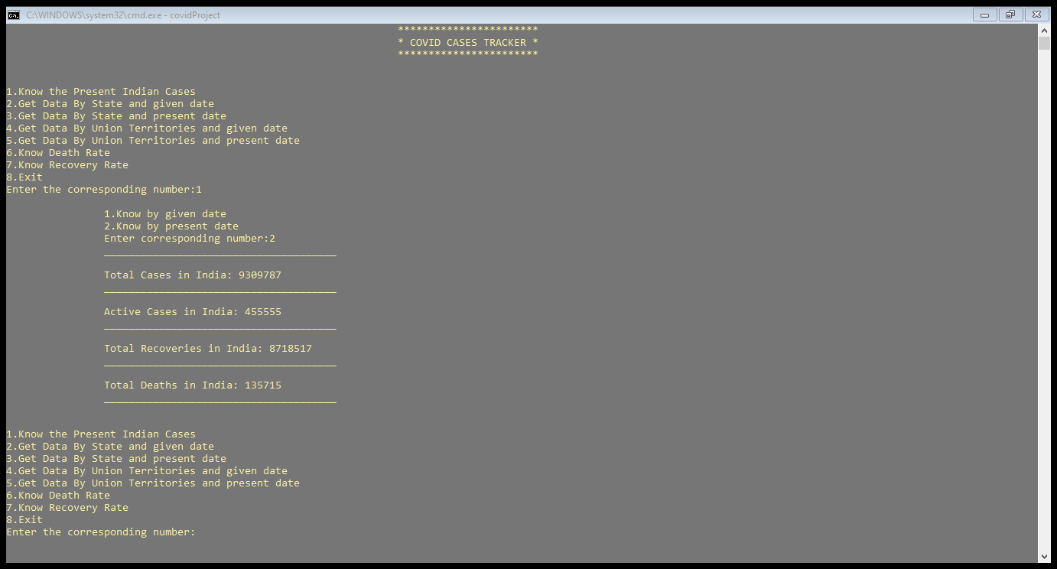

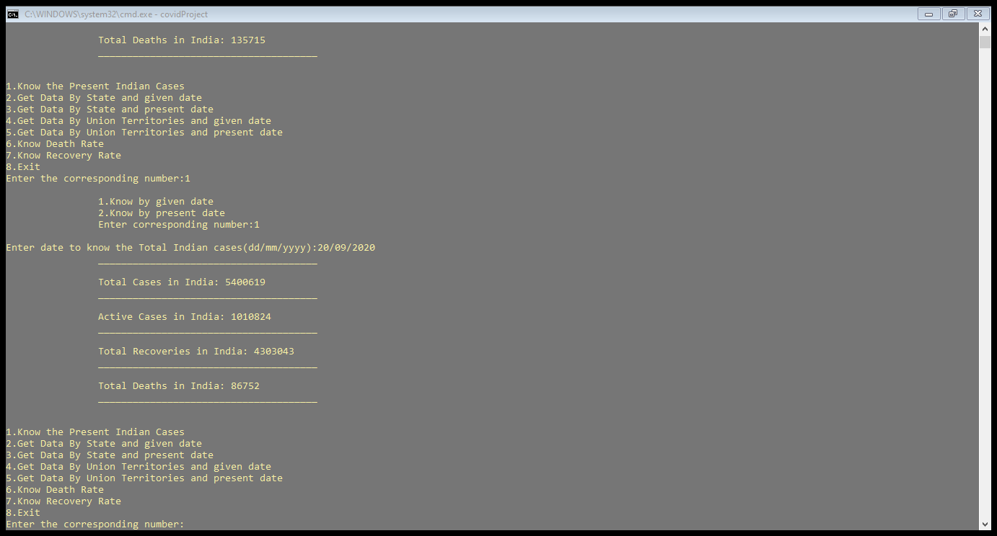

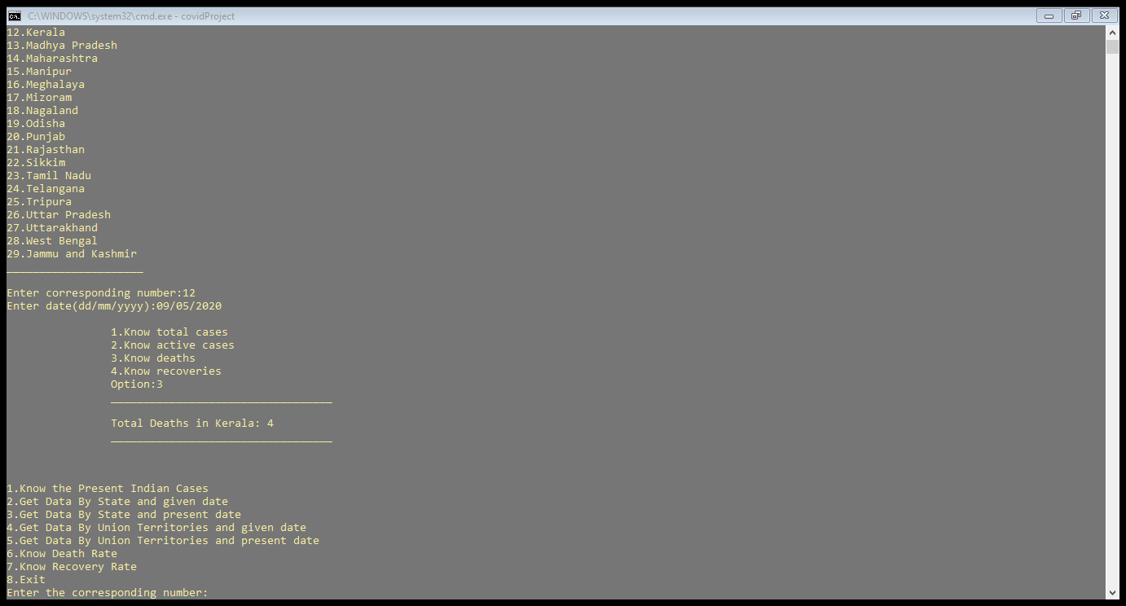

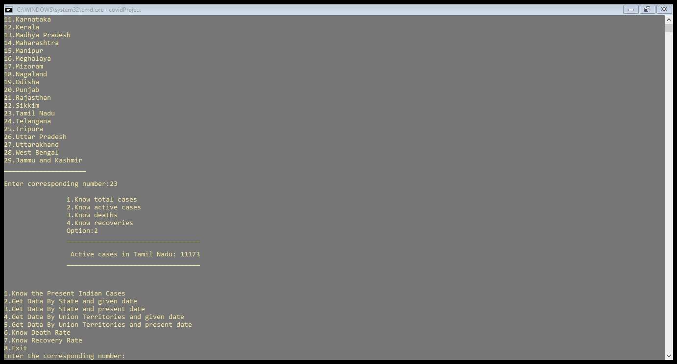

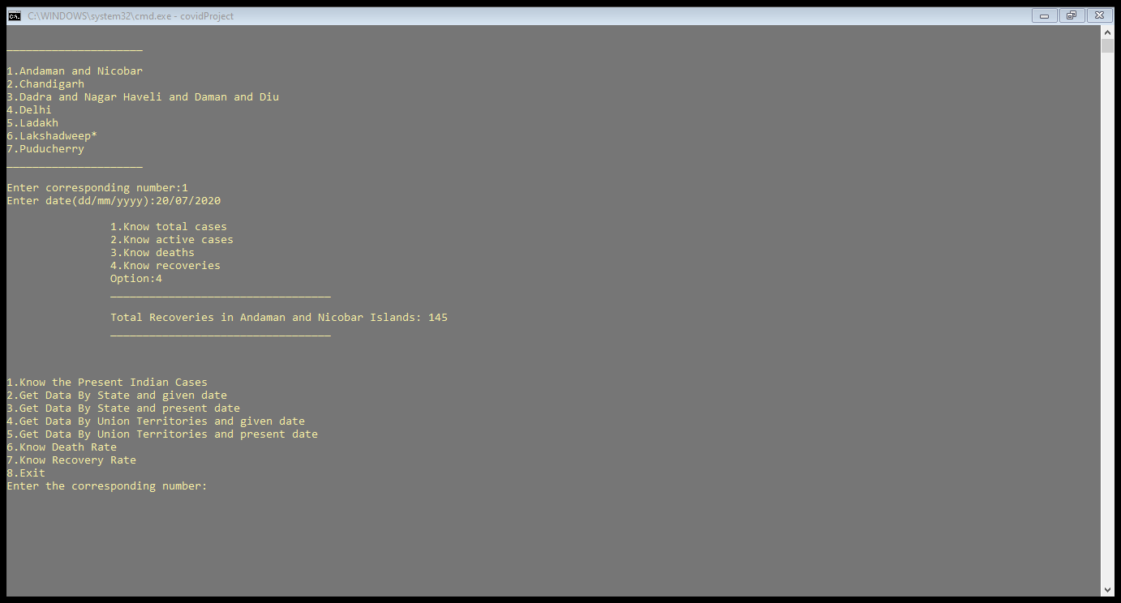

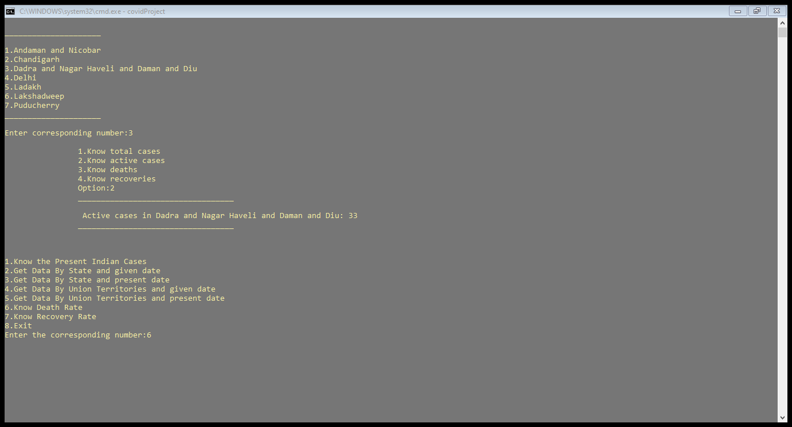

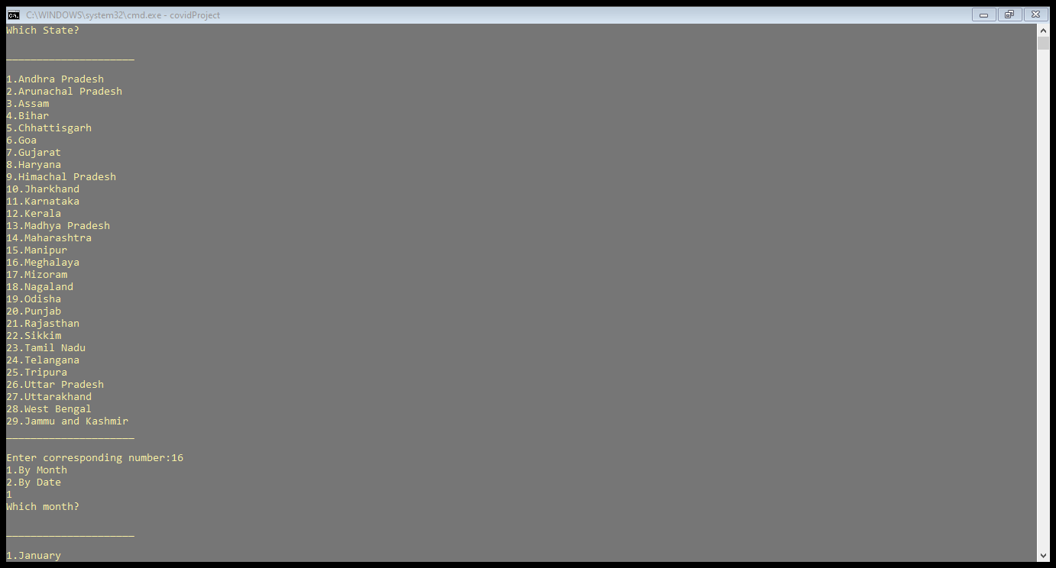

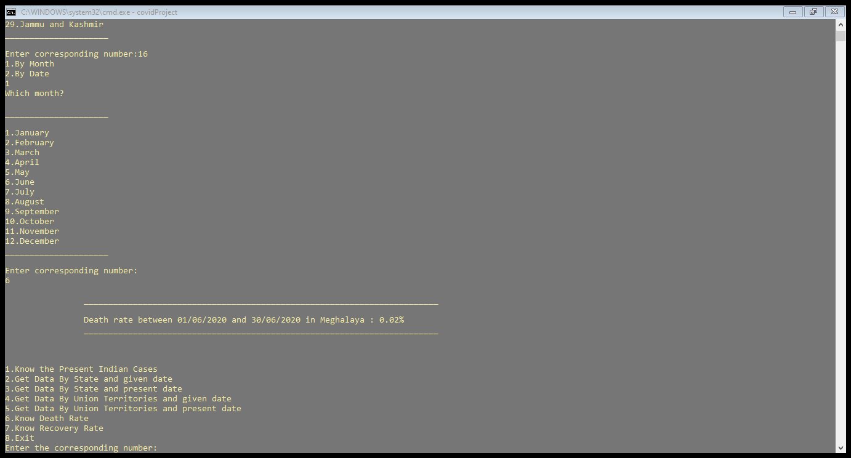

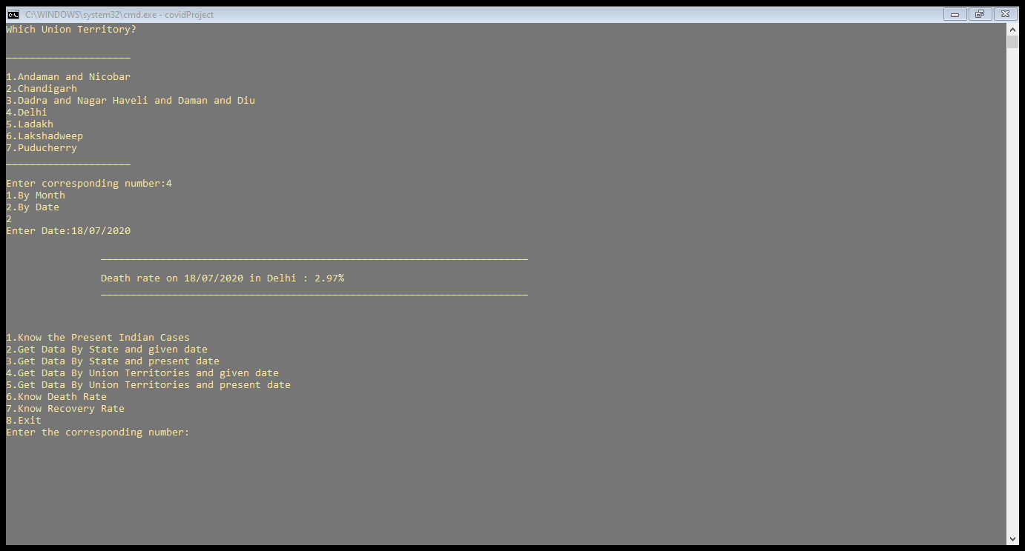

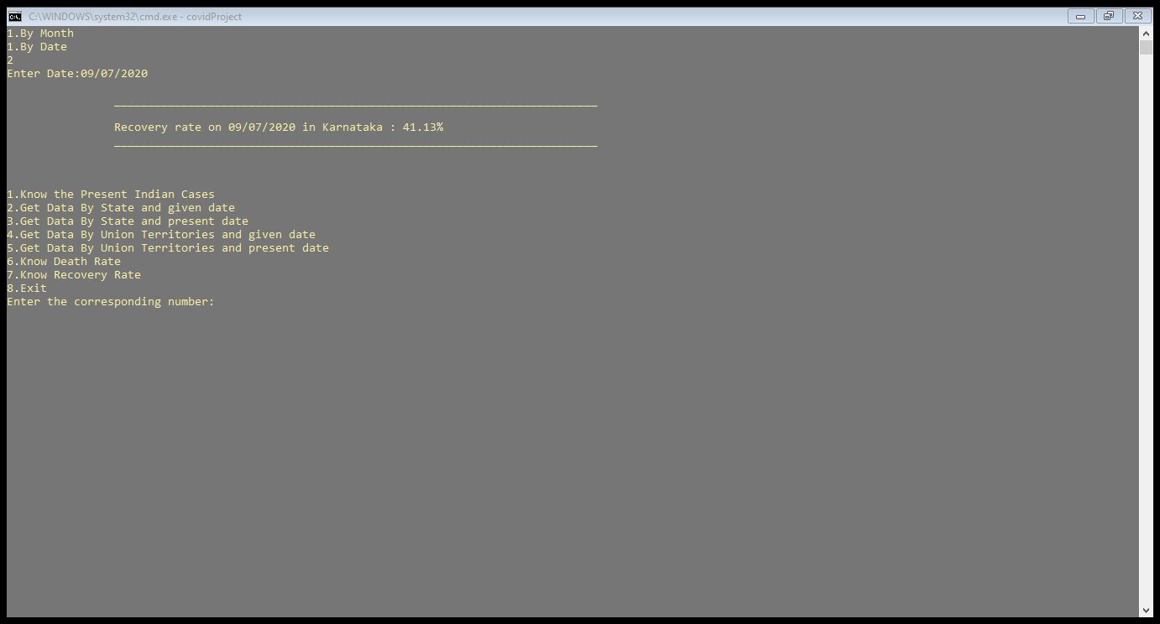

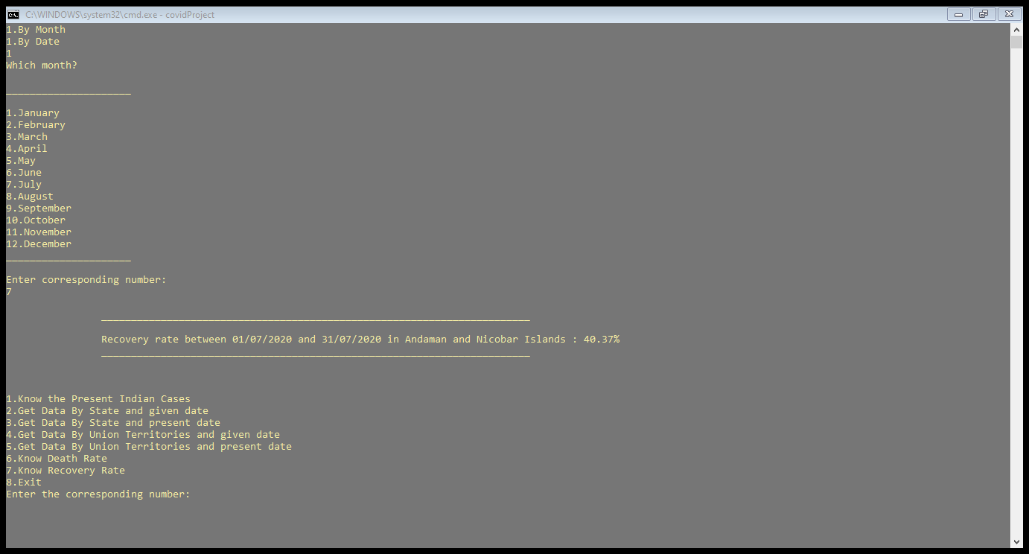

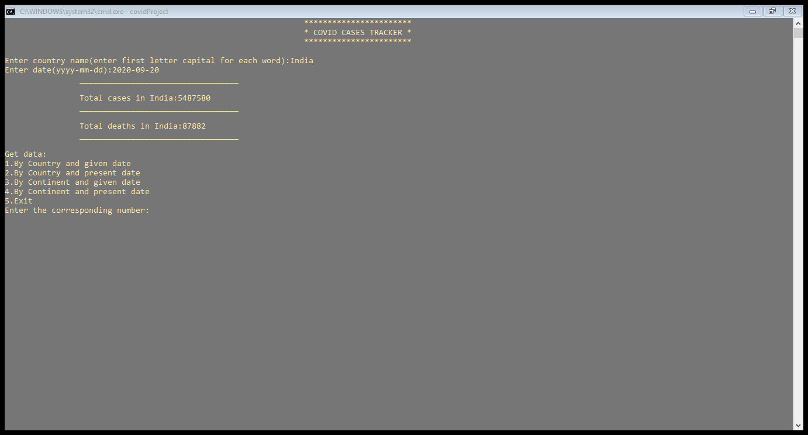

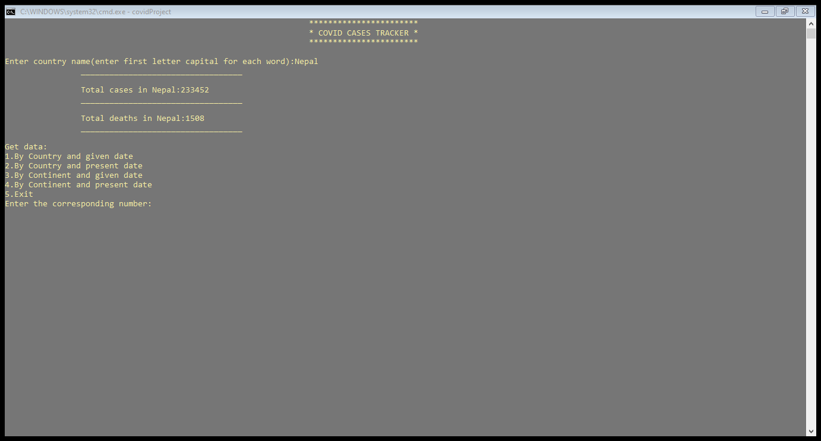

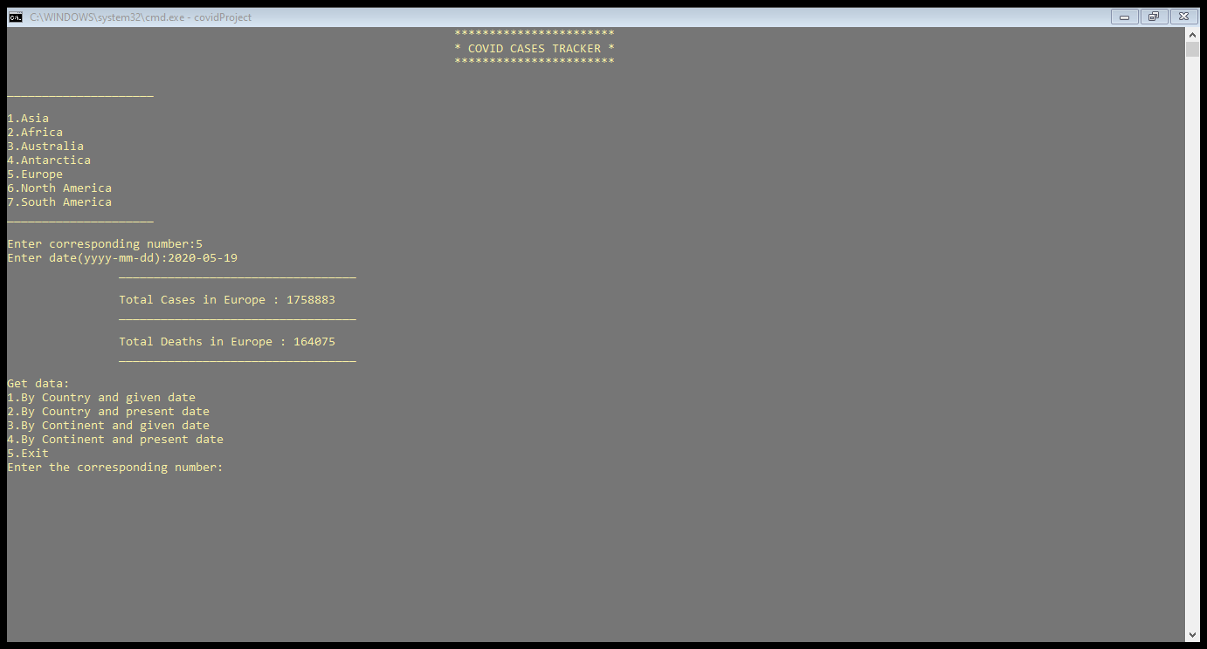

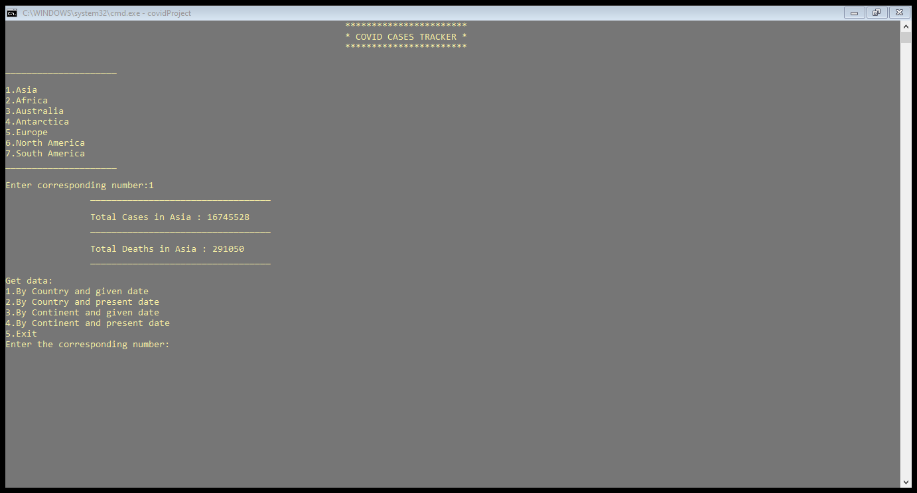

**What was the additional learning apart from the course programming for problem solving relate the ideas that you have gained implementing this mini project?**

Implementing this project in C Language has introduced us to different libraries such as: ‘windows.h’. We learnt how to read a csv file and do some calculations. We used the ‘windows.h’ library for controlling the display colours in a controlled manner.

Also, we have further improved in our knowledge in file-handling because of the vast amount of data manipulation we have done using text files.

Other than this, we have learnt the value of team spirit and have understood the intention behind working in teams. We have learnt to be team players.

**Discussion and Future work**

We conclude that this application is useful for everyone to view number of covid cases in any country/continent across the world. It can be operated very easily. Future work is that we wanted to display even current cases at any place and make this console application as a web application.

**References**

Reading and Writing data from and into csv file [**https://www.geeksforgeeks.org/csv-file-management-using-c/**](https://www.geeksforgeeks.org/csv-file-management-using-c/)

Visual Studio (for debugging errors)